Logging into Sage Service Operations (SSO)

Background
Sage 100 is the new accounting software package that we have purchased (it includes payroll, accounting, job costing, etc.) and has some future potential options (e.g. equipment management). SSO is a front end application designed for field staff. Think of it as an easier to use website where you will be entering Purchase Orders & Generating Daily Field Reports (including time entry) instead of having to go directly into Sage 100. Over time, we will continue to expand the use of SSO as the 1 source that our field needs to go to enter information.

Logging into SSO
- After you have received your invitation email to change your password (make sure to do that within 24 hours), you will then be able to log into the system.
- Go to: https://techs1.sageserviceops.com/login (you can copy and paste this into your internet browser (Note: please use this site for both your computer and cell phone – the application does not work well) & login to SSO.
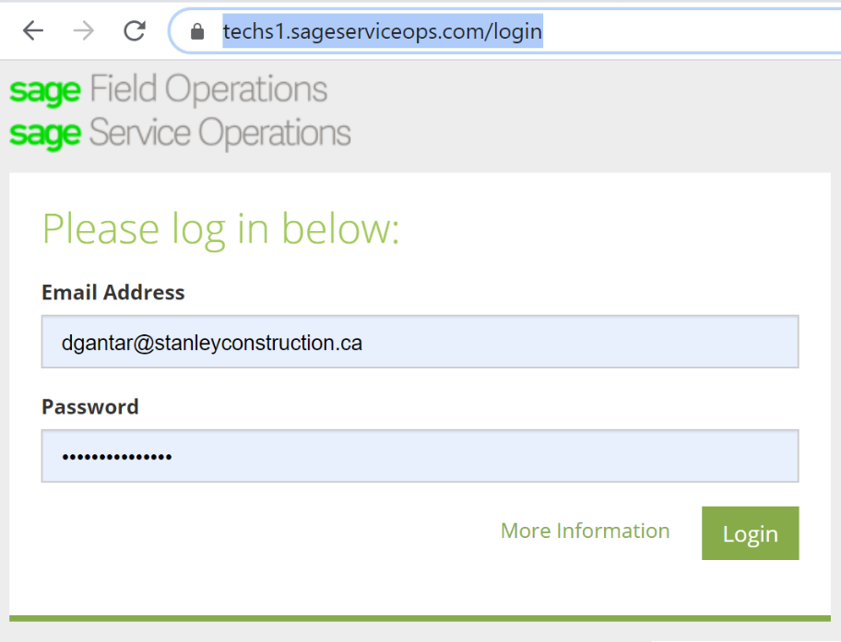
Your Stanley email is your login and you set up your password in Step 1.
- You will then land on a page in SSO that we will not currently be using (trying to find a way around that) but please click on “Jobs” (in a red rectangular box below) located on the left tab and it will take you to our listing of current projects.
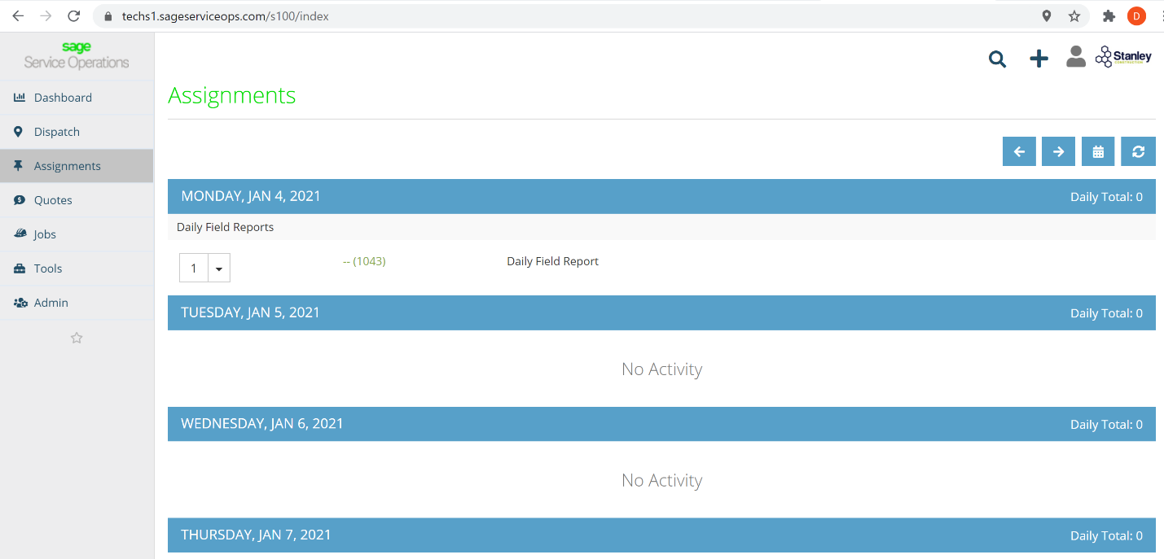
Notes
- SSO is live! When you enter data in here it will go to our accounting system so take your time and if you are not sure – please ask!

- Over time, we will continue to expand the use of SSO as the 1 source that our field needs to go to enter information – ideas to improve it will always be welcome.

- For easier future access you can either:
- Add this site to your bookmarks in your internet browser or
- For those of you that want an icon on your desktop open up your bookmarks after you have done the above step, click and hold your mouse on the SSO bookmark and then drag it over to your desktop.
Troubleshooting
- If you have not received the email inviting you to the system, please email Dave.
- If your password does not work, please email Dave and he will re-set your password.
- If you cannot figure out how to bookmark or to set an icon up on your desktop, Google: “how to bookmark in {insert your browser name or cell phone name}”.

