Daily Field Reports and Time Entry (PO’s)
Effective January 11, 2021, Daily Field Reports and Time Entry must be submitted using Sage Service Operations (SSO).
To create purchase orders:
- After logging into SSO and clicking on the “Jobs” link, choose the project you want to create the PO for (for our example below, we will be using 1043).
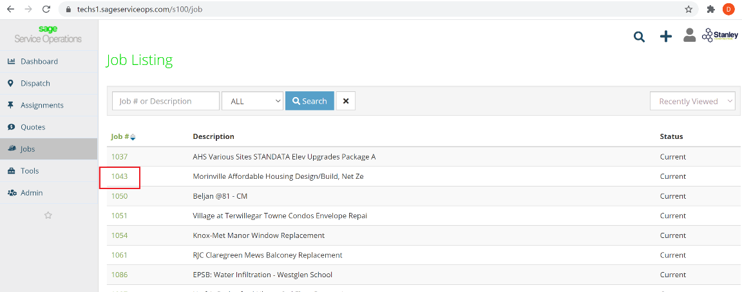
- In the Job you clicked on, you will see a second set of options beside the main ones on the left. Click “Field Reports” and then “Generate Field Report” will open – click that:
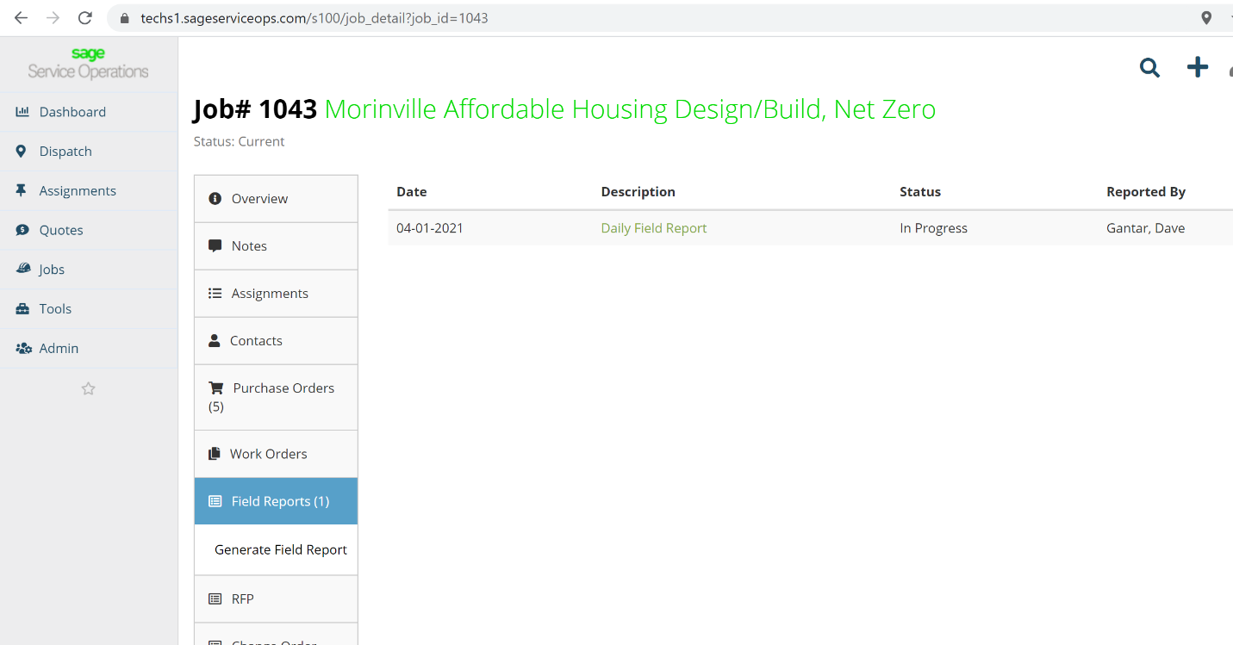
Note: When you click on “Field Reports” all previous field reports for that project are listed.

- The following screen will then come up:
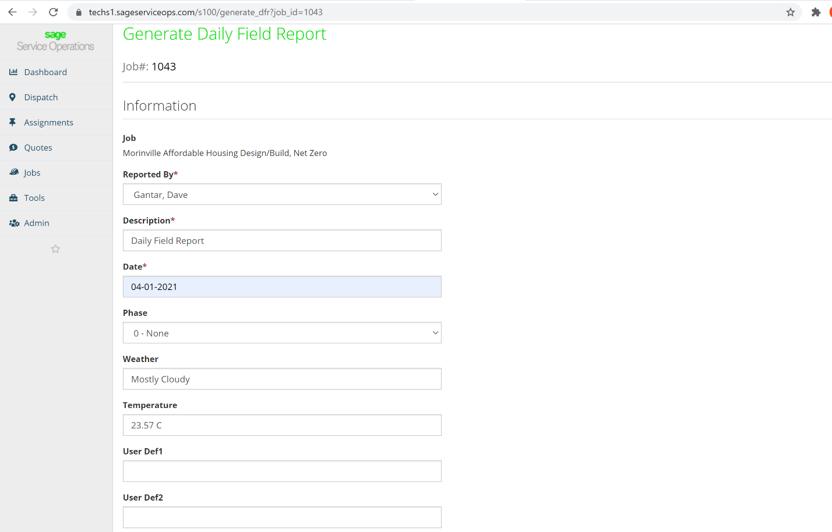
Date: Change to today’s date.
Phase: Choose “None”
Weather: Provide description of the weather
Temperature: Enter in temperature (you can put a range)
In the User Def1/2 fields: you can put anything you want
Then click: “Generate Field Report”

- You will then get the screen as shown on the next page. Here are the instructions for each of the items listed:
  - Overview – you can click on this to see the Overview and then choose “Update” if you want to update what you put on the first screen.
  - Assignments – please do not use this tab!
  - Notes – you can enter any notes you want to put on for the project.
  - Labor – this will be covered off separately in section 5.
  - Subcontractors – when you click this tab, you will have to click “Add Subcontractors” to enter information on each Subcontractor that was onsite.
  - Incidents – click this link to add an incident reports (full incident reports shodl still be attached to this report).
  - Meetings – enter all meetings that occurred onsite during the day.
  - Reports – when you have completed everything else, you can click this link to generate the field report.
  - Attachments – please add any rel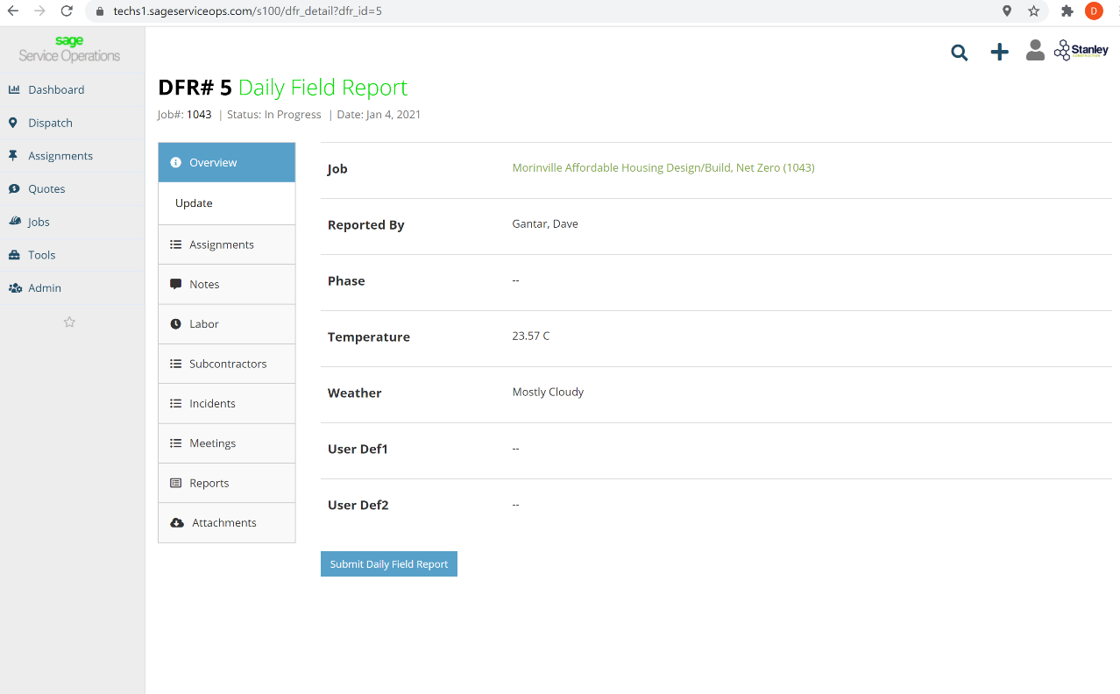evant attachments here including pictures.

- Employee Time Entry
For entering employee time into the system, please click on “Labor” and “Add Labor” to get the following screen:
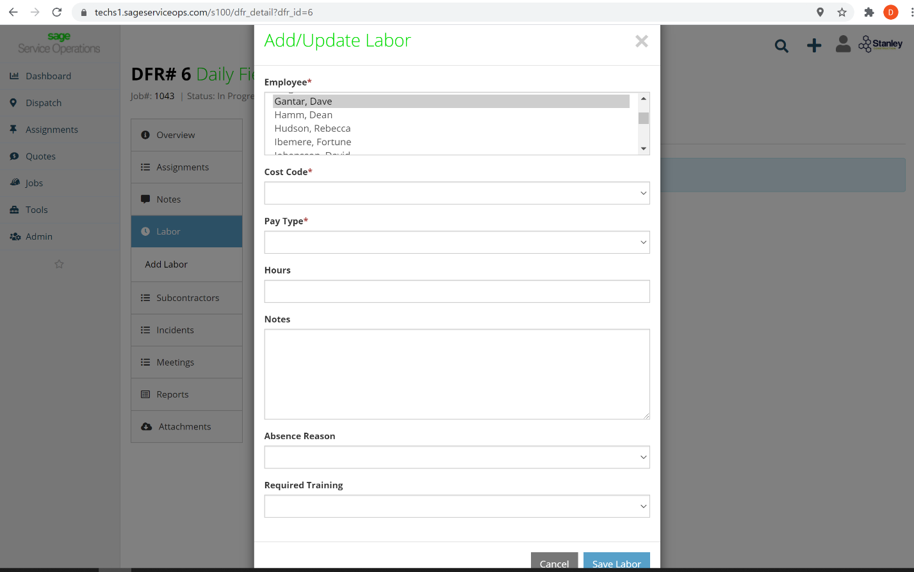

Please fill out the cells as follows:
Employee - choose the employee from the drop down list.
Cost Code – for employee time, the code is always going to be 10000
Pay Type – choose regular or overtime – if OT hours you must do a separate “Add Labor”
Notes – Add any notes you want to provide
Absence reason – Enter a reason from the drop down box if the employee was absent for any reason.
Required Training – leave blank
Once complete, press “Save Labor”

If you notice an error, you can change the information by clicking the down arrow and choosing “Update”

