Creating purchase orders for jobs

To create purchase orders for jobs:
- Open 6-6-1 Purchase Orders.
- Leave the Order# blank. Sage 100 will not allow duplicate purchase order numbers to be created. If a purchase order was created in SSO, the Order# will already be filled in.
- In the Order Date box, enter the date of the purchase order. Sage 100 Contractor automatically prefills the text box with today's date.
- In the Vendor box, enter the vendor. You can do this by typing Vendor number (if known) or by using the drop-down arrow to the right to see the list of Vendors
- In the Attention box, enter the name of the person to whom you are sending the purchase order.
- In the Description box, enter a brief statement about the order.
- In the Job box, enter the job number.
- If the job uses phases, enter the phase number in the Phase box.
- In the Approved box, enter the date the purchase order was approved.
- In the Scheduled box, enter the scheduled date of delivery.
- In the Delivery box, enter the actual date of delivery.
  - Note: If you are having items sent to a delivery site, enter the address information in the Address 1, Address 2, City, Province, and Postal text boxes.
- In the Via box, enter the means of delivery.
- In the Terms box, enter the payment terms.
- In the Status list, select the status of the purchase order. This defaults to 1-Open. Should there be an issue, change the status to 5-Void
- In the Type box, select the method in which payment is to occur.

- In the grid, for each item you want to purchase, enter where applicable:
  - In the Part# cell, enter the part number.
  - In the Description cell, enter a brief statement about the item.
  - In the Alpha Part# cell, enter the alpha part number.
  - In the Unit cell, enter the unit of measurement.
  - In the Quantity cell, enter the number of items you want to purchase.
  - In the Price cell, enter the cost for one item.
  - In the Cost Code cell, enter the cost code you want to use.
  - In the Cost Type cell, enter the cost type.
- Click File > Save.

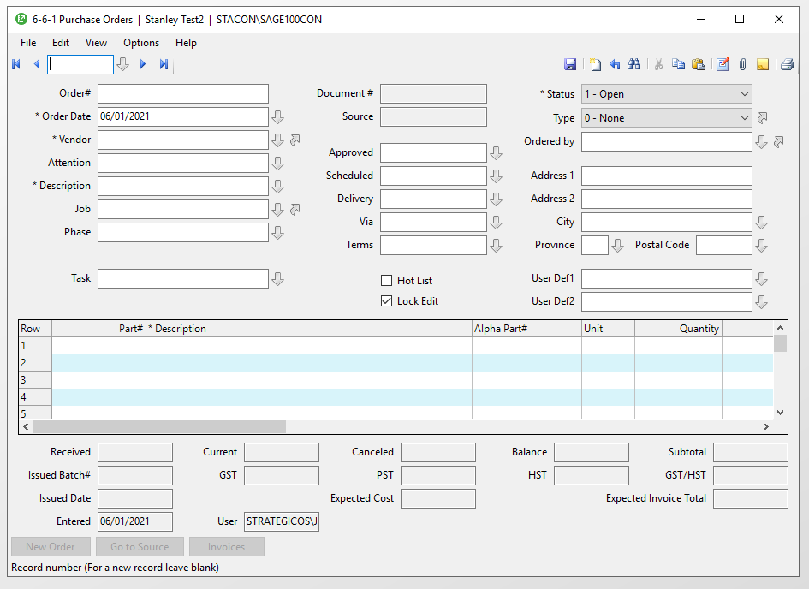

To create purchase orders by copying previous information:

- Note that the purchase orders will be in order of record #. The record # is automatically assigned in order of creation. The record # has no relevance outside of Sage 100.

- By using the drop-down arrow next to the scrolling buttons, a window displaying all the purchase orders that have been created. You can filter by status, or search by any field after clicking on that header

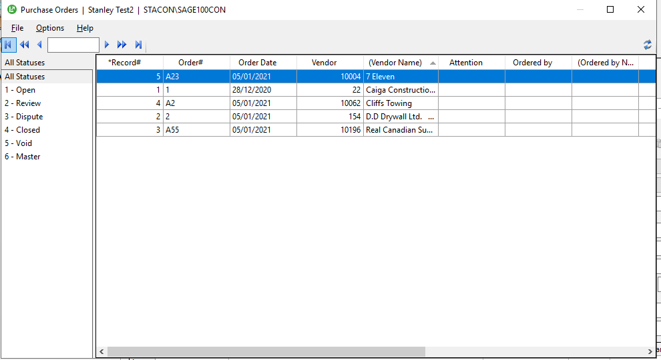

- Select the purchase order record you wish to copy

  - Under the Edit Menu – click copy purchase order
  - Under the File Menu – click new
  - Under the Edit Menu – click paste purchase order

- You now must change the purchase order number, as well as the other relevant details.

- Click Save

Purchase order statuses:

Status | Description
1-Open | Indicates the purchase order has been approved by someone with authority in the company to approve purchase orders.
2-Review | Indicates the purchase order should be reviewed by someone with authority in the company to review purchase orders.  Important.  Before creating an invoice, you should review the purchase order.  You can enter an invoice with a status of 2-Review, but the program warns you about it.
3-Dispute | Indicates a purchase order in dispute with the vendor. The authority reviewing the purchase order is disputing the charges, quantities, and so on, of the purchase order.
4-Closed | Indicates all items contained in the purchase order have been purchased or canceled.
5-Void | Indicates the purchase order is void.
6-Master | Tracks all materials to be purchased from the vendor for an entire project.  With a master purchase order, you can create individual purchase orders to the vendor. The master allows you to control the ordering and shipping of materials to the job site.

