Creating purchase orders (PO’s) February 13, 2021
Effective January 11, 2021, all Purchase Orders from Stanley must be generated using Sage Service Operations (SSO).
To create purchase orders:
- After logging into SSO and clicking on the “Jobs” link, choose the project you want to create the PO for (for our example below, we will be using 1043).
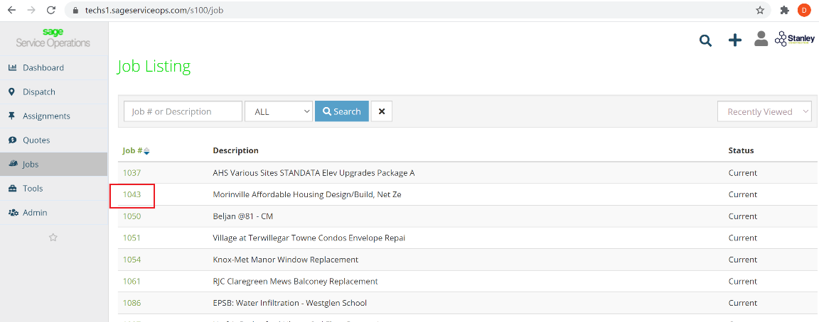
- In the Job you clicked on, you will see a second set of options beside the main ones on the left. Click “Purchase Orders” and then “Add PO” will open – click that: 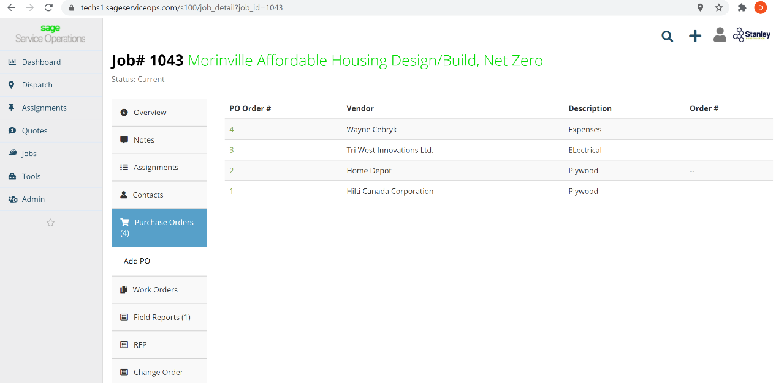
Note: When you click on “Purchase Orders” all purchase orders for that project are listed.

- At this point you will need to determine which type of PO you are creating:
- Subtrade/Vendor Purchase Order – these are POs that you will be issuing to another company to do work or supply materials THAT WILL be providing Stanley a future invoice that we will pay.
- Company Credit Card Expense – these are no longer handled as PO’s. Please hold onto the receipt and await your credit card statement at the end of the month for further instructions
- Personal Expenses – these are for any expenses that are personal expenses to you or one of the other members of the Stanley Team that are working on your project. This includes per diem, mileage, etc.
After deciding which PO Type you are inputting, please follow the instructions for that Type of PO as noted on the pages that follow.

- Subtrade/Vendor Purchase Order
Starting January 11, 2021, all Purchase Orders to Subtrades/Vendors must use SSO.
Step 1: Choose the Vendor that you want to issue the PO to & provide a brief description of what you want them to provide & make the Phase “0-None” (we are looking to remove this) and then click “Create PO”.
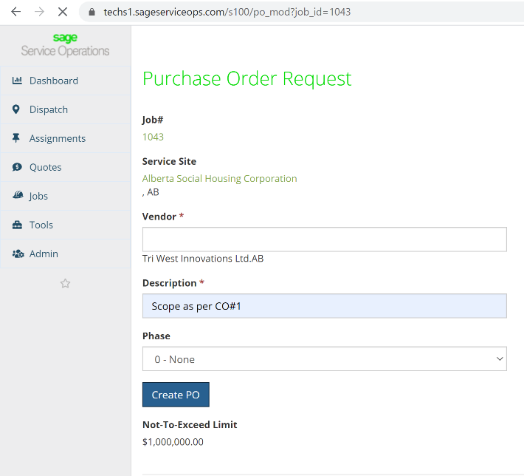
A few notes:
- You do not need to type the entire name of the Vendor (e.g. in this one I just typed “tri”) but you must choose from the drop down list.
- A Vendor must be entered in Sage 100 BEFORE you can issue a PO. If the name does not show up in the drop down, please email your Project Manager and ask to set them up as a Vendor. You will need to provide: company name & an email address where payment notices are to be sent.
- Your PO limit is located at the bottom of the page – I suspect that this will need to change as we move forward so please keep in touch with me.

Step 2: You will then be taken to the page below. The PO number at the top of the page (this is automatically generated by the system and may look weird to some of our current vendors/subtrades). From here you can click:
    - “Update” to make changes to the Vendor or the Description
    - “Notes” to add special notes to the PO
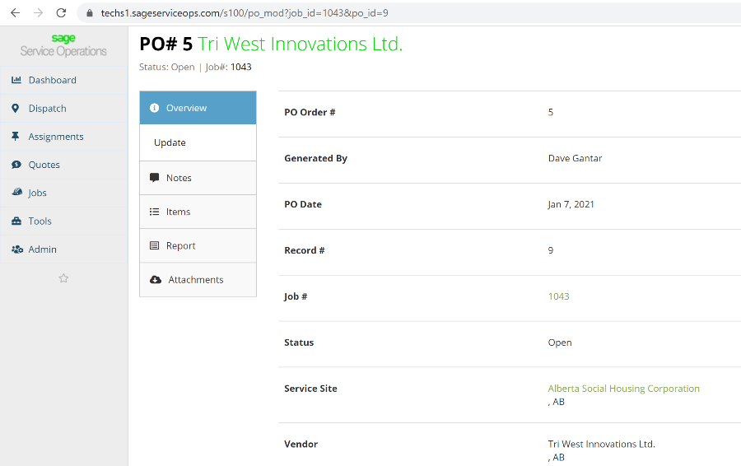

    - “Items” and then “Add Item” where you will then see the following:
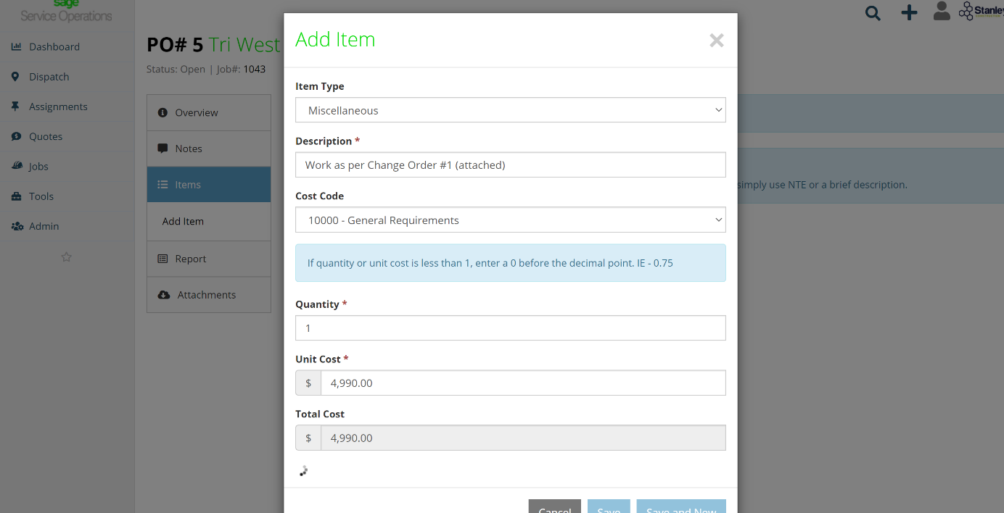

Item Type: Change to Miscellaneous
Description: You may want to put a little more detail.
Cost Code: If the project budget has a cost code for this, please to enter here BUT for most items you are doing it should be “10000”
Quantity and Cost: Enter as per your PO (Exclude GST – any $ amount entered in here should include NO GST) & then click “Save”
You can then:
  - enter additional Line Items by Clicking “Add Items” or
  - add attachments by clicking “Attachments”.

Step 3: When you have entered in all information, you can then click on “Reports” where you can review the PO details, confirm the information and then enter email addresses to who you want the PO to be sent.
- Company Credit Card Expense
These are no longer handled as PO’s. Please hold onto the receipt and await your credit card statement at the end of the month for further instructions.
- Personal Expenses
Starting January 11, 2021 all expenses must have PO’s entered into SSO. For the odd scenario where an employee requires this to be entered, please do this for them.
Step 1: When choosing the Vendor, you must type in EXP in the “Vendor” box and then choose the appropriate employee name after that.
Step 2: You will then be taken to the page below. From here you can click:
    - “Update” to make changes to the Vendor or the Description
    - “Notes” to add special notes to the PO
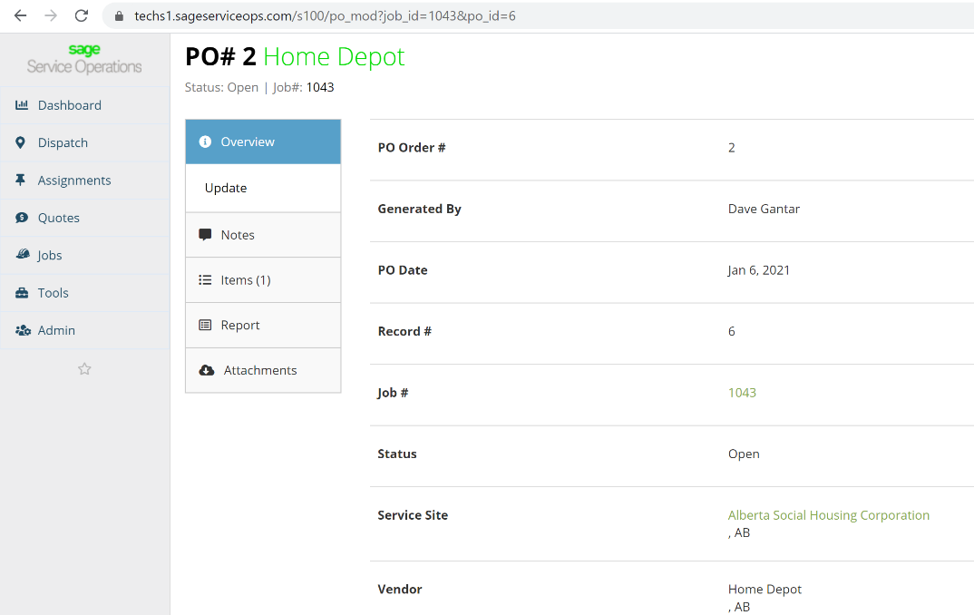
    - “Items” and then “Add Item” where you will see the following:
Item Type: Change to Miscellaneous
Description: You may want to put a little more detail.
Cost Code: If the project budget has a cost code for this, please to enter here BUT for most items you are doing it should be “10000”
Quantity and Cost: Enter as per your PO (Exclude GST – any $ amount entered in here should include NO GST) & then click “Save”
Please enter as many line items as there are expenses – for example, you can add multiple receipts as individual line items to 1 PO!

Step 3: You must attach receipts for each expense to the PO. Please take a photo of the receipt and attach by clicking “Attachments” and then finding the photo on your phone or computer.

Step 4: When you have entered in all information, you can then click on “Reports” where you can review the PO details, confirm the information and then (as per the screen shot below) in the Signature Area, change ‘Contractor” to the name of the employee and then for most phones and computers sign it.
Please send the report and receipts to the Site Supervisor OR your Coach. Once they approve they must send their approval (in the email is good), PO and receipts to: accounting@stanleyconstruction.ca for processing.

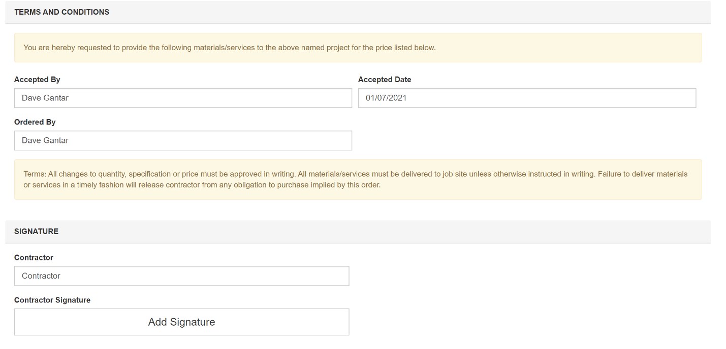

Note: Paper expense reports will no longer be accepted.

