Change Orders (Project Management)
The 6-4-1 Change Orders window has two tabs, Prime Change Details, and Budget and Sub Change Details. To make changes to a job’s contract amount (revenue), you enter the change on the Prime Change Details tab. To change a budget or subcontract, you enter the changes in the Budget and Sub Change Details tab (expenses).
To enter prime and sub changes:
- Open 6-4-1 Change Orders.
- In the Job box, enter the job number.
- In the Description box, enter a brief statement about the change order or use the lookup window to enter an existing description.
- Leave the Change# box blank. Sage 100 Contractor suggests the next number in sequence automatically.
- In the Order Date box, enter the date of the change order.
- The Status list will start out at “2 – Open”. Once the change order is approved, change the status to “1 – Approved”
- On the Prime Change Details tab, for each item affecting the job contract (revenue):
  - In the Description cell, enter a brief statement about the change work.
  - In the Estimated cell, enter the amount of change to the contracted amount.
  - If you want to include overhead, enter the rate in the O/H Rate cell.
  - If you want to include profit, enter the rate in the Profit Rate cell.
  - The Requested cell will add compute the estimated amount, plus any overhead and profit if you elected to enter a % amount in step 7(c) or 7(d). You can also manually enter a Requested amount.
  - In the Cost Code cell, enter the cost code using the lookup window.
  - In the Cost Type cell, enter the cost type using the lookup window.

- In the Budget and Sub Change Details tab, for each item affecting the budget (expense):
  - In the Description cell, enter a brief statement about the change work.
  - If you want to change the budgeted hours, enter the amount of change in the Budget Hours cell.
  - If you want to change the budgeted units, enter the amount of change in the Budget Units cell.
  - If you want to change the budgeted amount, enter the amount of change in the Budget Amount cell. Note – Just enter the final dollar amount before tax. This is not a (Quantity * Price) field.
  - If the change work affects a specific vendor, enter the vendor number in the Vendor cell.
  - If this change with vendor in step 8(e) means a change to an existing subcontract, enter the record number of the Subcontract cell. The dropdown menu is there to assist in selecting the appropriate subcontract.
  - In the Change# cell, enter the change order number you want to assign the subcontract.
  - In the Status cell, select the sub change status. (If this status is 1-Approved, then the 6-7-1 Subcontract will show the original, change, and new total)
  - In the Cost Code cell, enter the cost code.
  - In the Cost Type cell, enter the cost type.
- Click File >Save.

Affects of Prime Change Details
Job record after Change Orders are entered/approved:
- The original contract amount will always appear on the 3-5 Jobs record
- Click on the Contract Summary button at the bottom
- The Contract Summary window will appear
  - If the status of change order is “2-Open”, the requested column amount appears in the ‘open changes’ section of the Contract Summary.
  - If the status of the change order is “1-Approved”, the approved column amount appears in the ‘changes to date’ section of the Contract Summary.
- See examples 1 & 2 below

Affects of Budget and Sub Change Details
Subcontract record after Change Orders are entered/approved:
- The 6-7-1 subcontract record has an original subcontract, changes, and new subcontract columns in the grid
- Once the change order has a vendor & subcontract selected, the budget amount entered in the grid of the change order carries through to the applicable 6-7-1 subcontract
- See examples 3 & 4 below

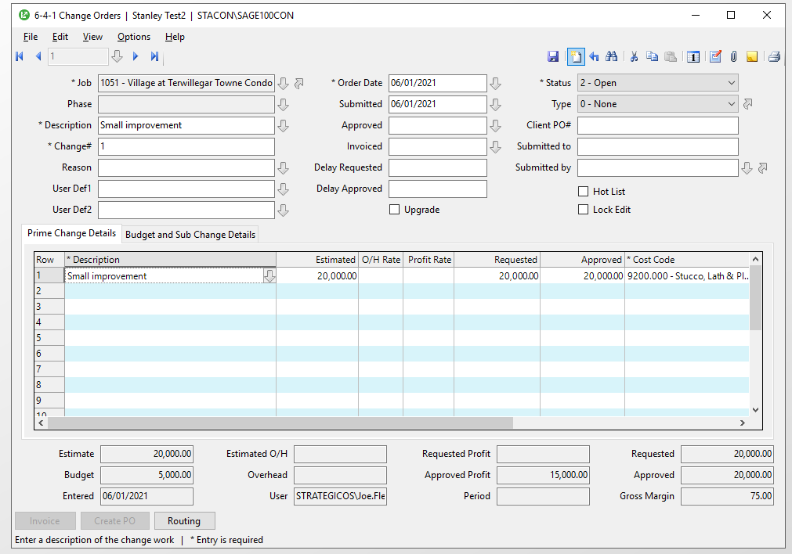

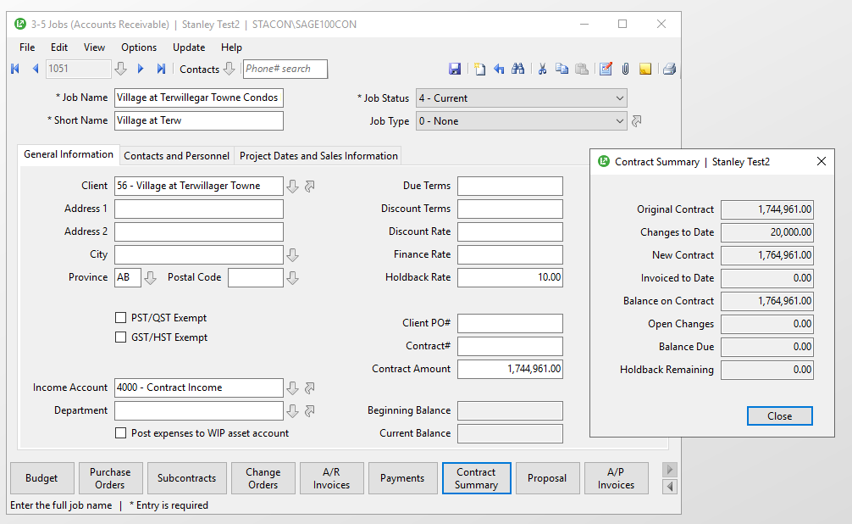

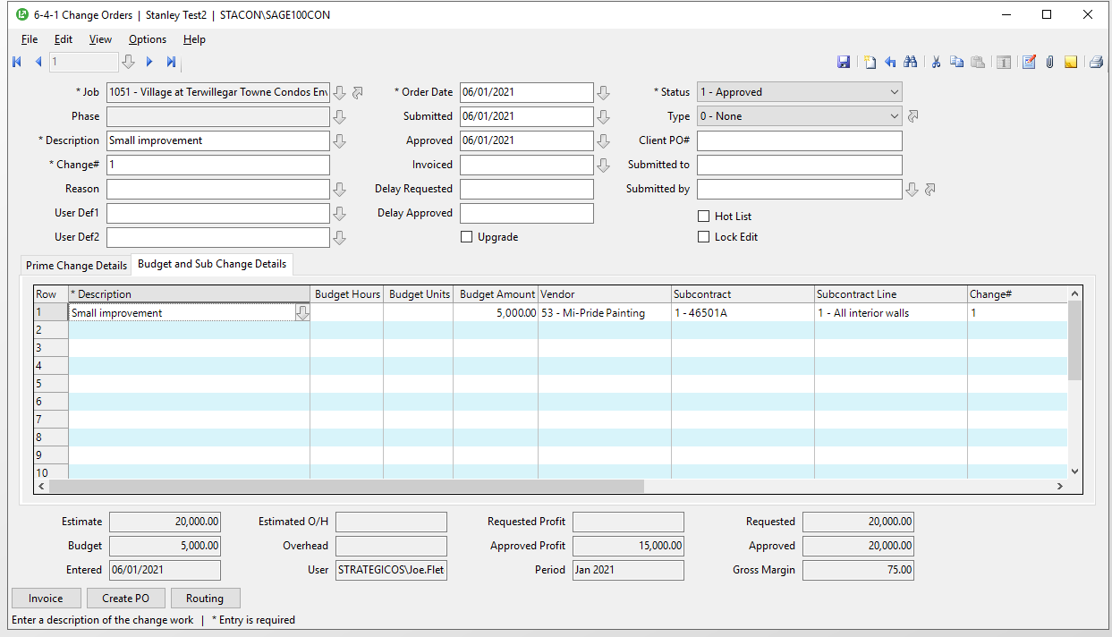

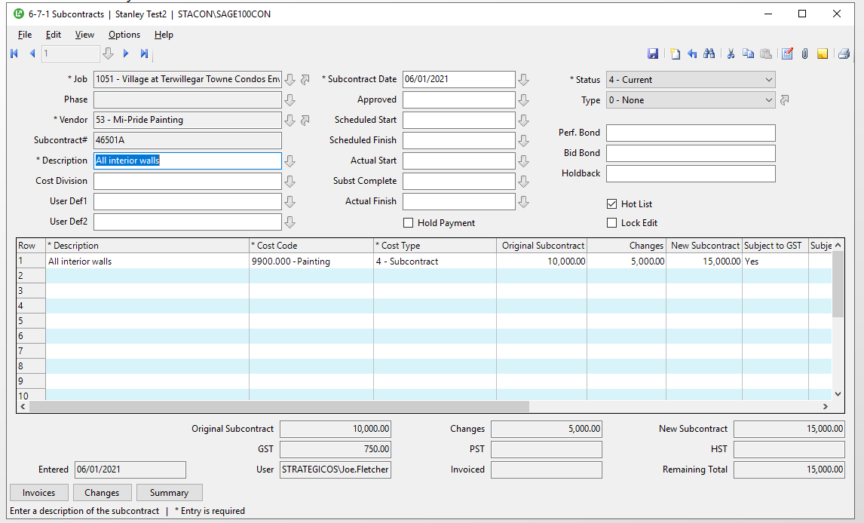

About updating costs in progress bills from change orders
You can automatically or manually update costs in the progress bill from change orders. Choose from two methods to automatically update the costs from change orders. You can either incorporate the changes to costs in the individual cost codes, or include the total amount of the change order as a separate line item.
Important! When using the Append as New Lines option, do not change the Description values as you have entered them into the grid. Sage 100 Contractor uses an exact match of the text in the Description column to match the items from the Change Order grid to the Progress Billing grid.

Method 1: Incorporate changes to costs in the individual cost codes
When you select the Add to Existing Lines option in 3-7 Progress Billing, Sage 100 Contractor only updates cost codes or divisions present in both the change order and the progress bill. If the change order contains cost codes that do not correspond to cost codes or divisions in the progress bill, Sage 100 Contractor will notify you. Review the new cost codes in the change orders, and if necessary, manually add the new cost codes or divisions and update the progress bill again. Sage 100 Contractor displays the amount of change to each cost code in the Changes column and the new contract amount in the Contract column.

Method 2: Include the total amount of the change order as a separate line item
Instead of updating the individual cost codes, you can append each change order as a separate line item at the end of the progress bill. Suppose the client approves change order number 1, and you only want to show the total amount of the changes on the progress bill. When you select the Append as New Lines option, Sage 100 Contractor creates a separate line for each change order. Sage 100 Contractor inserts the statement Change Order #1 in the Description column, and displays the total amount of the change order in the Changes column and the new contract amount in the Contract column.

