Entering subcontracts

To enter a subcontract:
- Open 6-7-1 Subcontracts.
- In the Job box, enter the job number.
- In the Vendor box, enter the vendor number of the subcontractor performing the work.
- The Subcontract# box will be auto-populated with the next subcontract number. Sage 100 will not allow duplicate subcontract numbers to be created.
- In the Description box, enter a brief statement about the subcontract, for example, Electrical work.
- In the Subcontract Date box, enter the date on the contract.
- Set the Status to “3 – Contract”.
- For each item in the subcontract:
  - Do any of the following, as needed:
    - In the Approved box, enter the date the subcontract was approved.
    - In the Scheduled Start box, enter the date the subcontract is scheduled to begin.
    - In the Scheduled Finish box, enter the date the subcontract is scheduled to end.
    - In the Actual Start box, enter the date the subcontract actually started.
    - In the Subst Complete box, enter the date when most of the work is to be completed.
    - In the Actual Finish box, enter the date when the subcontract is to be completed.
    - In Pref Bond, Bid Bond, and Holdback boxes enter values.

  - Using rows in the grid:
    - In the Description cell, type a description, or enter a description using the Quick List, and then press the Enter key.
    - In the Cost Code cell, type a cost code, or enter a cost code using the lookup window, or accept the default cost code, and then press the Enter key.
    - In the Cost Type cell, type a cost type, or enter a cost type using the lookup window, or accept the default cost type, and then press the Enter key.
    - In the Original Contract cell, enter the dollar amount of the subcontract.
- Click File > Save.
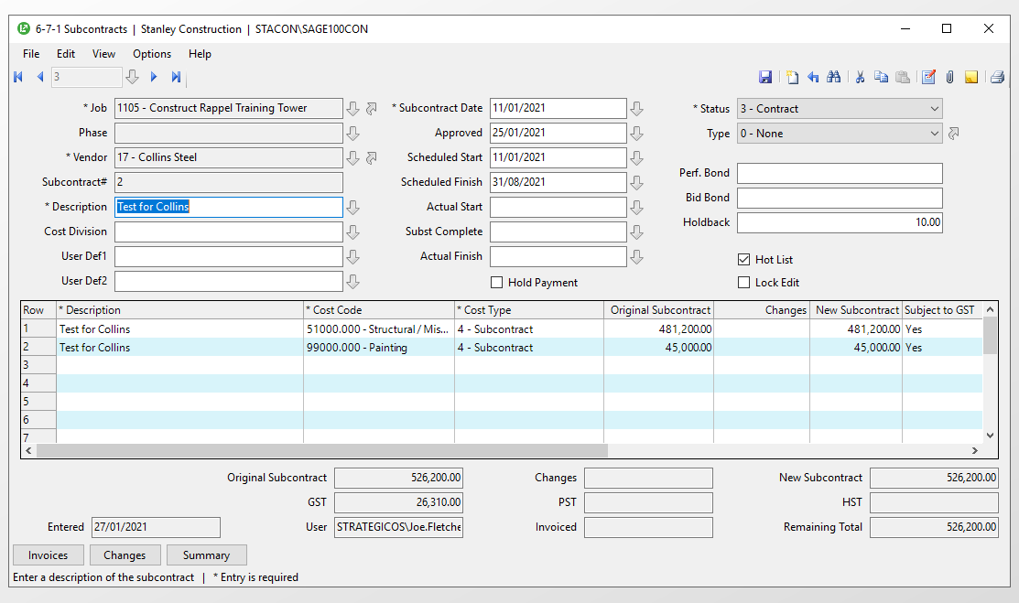

- Once the final contract is signed, click the attach button (or click the edit menu, then Attachments) and save a copy to this record.

