Creating progress billing for jobs
The accounting department will have set up the job once the budget has been agreed upon. Before any progress bills have been created, the window will look like this example:
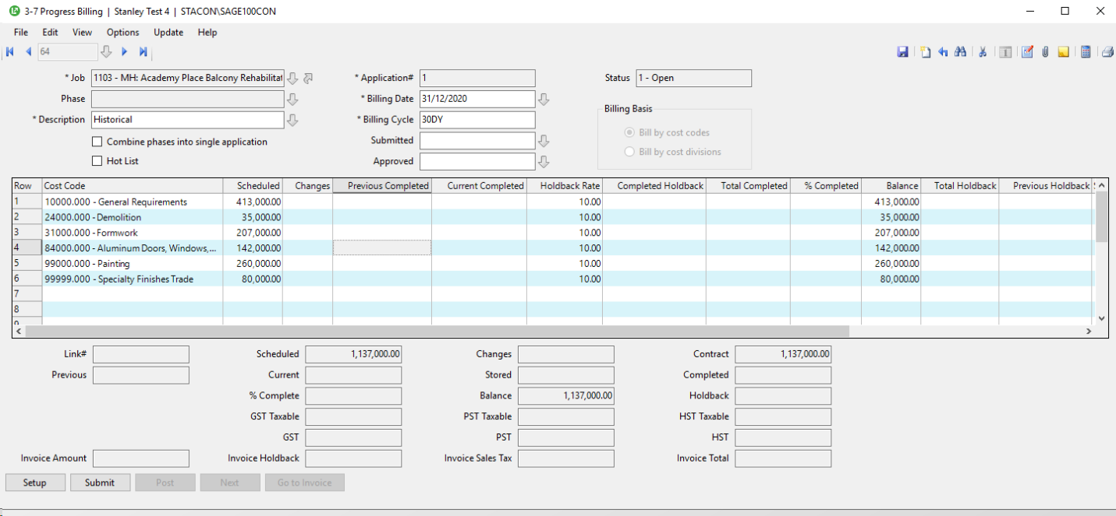
Overview of Statuses
- When you create an application, Sage 100 Contractor assigns it status 1-Open.
- After you have submitted the application, submit the record in Sage 100 Contractor by clicking the Submit button. Sage 100 Contractor then changes the application’s status to 2-Submitted.
- When the billing is approved, post the billing by clicking the Post button. Sage 100 Contractor creates an invoice, posts it to the general ledger, and then changes the application’s status to 3-Posted.
- When you want to create the next application, click the Next button. Sage 100 Contractor assigns the posted application status 4-Closed, moves the costs from the Current Completed column to the Previous Completed column, and advances the number in the Application# text box.
.
Important!
From time to time you may need to void an invoice for a progress billing. Voiding the invoice in the 3-2 Receivables Invoices/Credits window does not void the progress billing. Therefore, you should void the billing in the 3-7 Progress Billing window.

Entering setup data for progress bills
To create a progress bill, you must provide some basic information in the Progress Billing Setup window, such as the name of the architect, the architect’s job number for the project, the income posting account, and the holdback rates.
To enter setup data for a progress bill:
- Open 3-7 Progress Billing and click the Setup button at the bottom left.
- In the Progress Billing Setup window, in the Architect text box, enter the vendor number of the architect or engineer.
- In the Architect’s Job# text box, enter the number the architect uses to refer to the job.
- In the Income Account text box, you should see ‘4000 – Contract Income’.
- In the Holdback section, enter/confirm the rate of holdback.
- On the menu bar, click Save.

Creating new progress bills for jobs

Overview of Grid Columns

- The Cost Code column is populated with those that you will find in your Project Budget
- The Scheduled amounts do not change. They represent the total amount of the contract that you will be invoicing the customer split by cost code.
- If there is an approved change order, the amount of revenue to invoice will appear in the Changes column
- The Previous Completed is the amount that has been invoiced previously
- The Current Completed is the amount that you want to invoice. This amount is tied to the % Completed. You will only enter ONE of these amounts, and then Sage 100 will calculate the other.
- The Holdback Rate percentage defaults from the Setup section and the Completed Holdback refers to the amount of Holdback for the current invoice
- Total Completed and Total Holdback will equal the amount of Current Completed + Previous Completed and Completed Holdback + Previous Holdback respectively.
- The Balance is the amount remaining on the contract to invoice

To create a new progress bill for a job:
- Open 3-7 Progress Billing.
- In the header:
  - In the Description text box, enter a brief statement about the work completed.
  - Select the Hot List check box. (This progress billing will also appear in the 6-12 Project Work Center).
  - The Application# will auto-populate.
  - In the Billing Date text box, enter the date ending the period for which you are submitting the request.
  - In the Billing Cycle text box, enter the billing cycle.
In Sage 100 Contractor, a cycle is represented by ##DY (a number of days), ##MO (a number of months), and ##TH (a specified day every month). You replace the ## symbols with the number of days or months, or the day of the month for the processing cycle. For example:
    - 30DY means due every 30 days.
    - 02MO means due every two months.
    - 25TH means due on the 25th day of each month. Sage 100 Contractor displays the 25th of the month following the invoice date when you enter a new invoice for a vendor
  - In the Submitted text box, enter the submittal date.
  - In the Approved text box, enter the approval date.
- If you have issued change orders for the job, update the progress bill application to reflect the affects of the change orders. This is done by selecting Update-Change Orders [pick your preferred method]
- Update the costs incurred-to-date by selecting Update-Total Completed-From Cost Amounts. What this will do is look at your Job-Costs-to-date vs your previous-invoicing-to-date. It will then suggest a Current Completed amount to invoice that will make the Total Completed equal the Job-Costs-to-date.
Important! – This suggested billing amount will not include any profit!! Only the recovery of all Job Costs. It will even suggest a refund of a previously billed cost code if the invoiced amount-to-date exceeds the Job-Costs-to-date.
See the image below that has a Current Cost Summary Report and the related 3-7 Progress Billing screen after updating the costs.
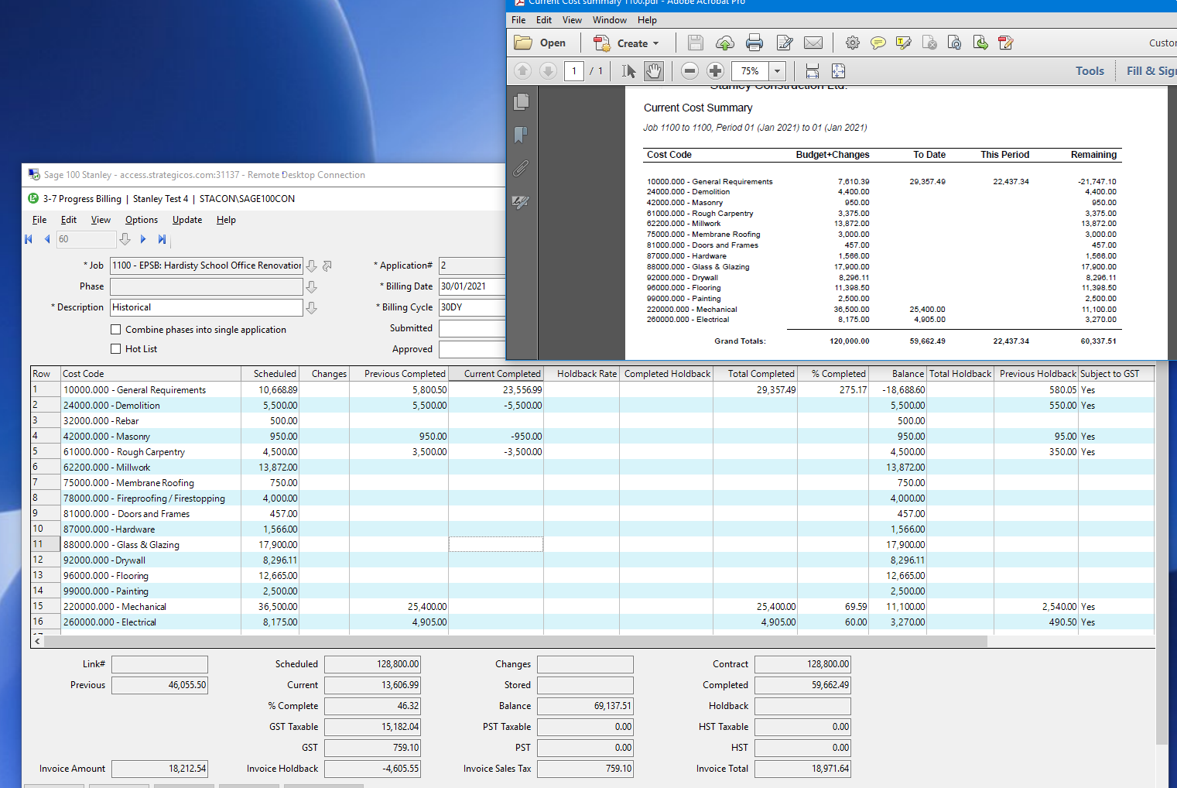

- You can then adjust the amounts in the Current Completed cells if you prefer to enter the dollar amounts you want to invoice by cost code, OR the percent of work completed in the % Completed cells which will calculate the dollar amounts to invoice for you. You can pick either method, but you cannot perform a hybrid, as you will see in Step 6.
- Calculate the project costs. The calculation grid window will ask you if you want to compute Current Completed based on your entered %s, OR if you want to compute the %s based on the Current Completed amounts you entered. Once calculated, save your progress.
- Print the Progress bill application. Select Report 21.
- On the Options menu, click Submit Application. In the Submitted text box, enter the date you submitted the request. If you leave the Submitted text box blank, Sage 100 Contractor enters the current date for you.
- Once the Progress bill is approved, in the Options menu, click Post Application. Sage 100 will take you to the 3-2 Receivable Invoices/Credits window and create an invoice based on the Progress application.
- When ready to invoice again, click Next to setup the next Progress bill application.

Releasing holdbacks for progress bills
You can bill for work and release holdbacks on the same billing. After you create or update the progress bill, select Update-Release Holdback. This will recalculate the invoice after changing all the Holdback rates to zero.
To release holdbacks only for specific line items, delete the rate in the Holdback Rate text box of each line item for which you want to release holdbacks. Then calculate the application.
Once you have the desired amounts, post the invoice.

Voiding progress bills
You can void an application that has a 4-Closed status. If the application precedes a series of applications, Sage 100 Contractor reopens the application, assigning it 2-Submitted status, and voids the subsequent applications. If you have posted an application, and payments have been made to the invoice, you must reverse the payments before voiding the application.
Suppose you have just created application 3. However, application 3 contains an error caused in application 2. To remove the error, it is necessary to correct application 2 and recreate application 3. When you void application 2, Sage 100 Contractor changes its status from 4-Closed to 2-Submitted. In addition, Sage 100 Contractor changes the status of application 3 to 5-Void. You can then make the necessary adjustment to application 2, and from it create application 3.
To void a progress bill:
- Open 3-7 Progress Billing.
- Using the data control, select the record.
- On the Edit menu, click Void Application.

Creating a holdback billing
To create a holdback billing:
- Open 3-2 Receivable Invoices/Credits.
- Select Create Holdback Billing in the Options menu.
- Select a job in the Job dropdown menu.
- Click [Display Invoices].
- In the top right, do one of the following:
  - To manually enter billing amounts, select the Manually enter billing amounts option and enter the amount in the Amount to Bill column. When initially clicking the field in the Amount to Bill column, a default value is shown. You can accept that value or enter your own amount.
  - To have the holdback remaining amount copied to the Amount to Bill column for each invoice, select the Bill All Remaining Holdback option and click [Calculate Billing Amounts].
  - To adjust the remaining holdback to a percentage amount of the invoice total, select the Adjust remaining holdback to { } % of Invoice Total option, enter the desired percentage, and then click [Calculate Billing Amounts].
- Click [Create Bill].
- In the 3-2 Receivable Invoices/Credits window:
  - Enter an invoice number in the Invoice# field.
  - Enter the due date for the payment in the Due Date field.
  - Enter the date when the discount will expire in the Discount Date field.
- Click File > Save.

